Manual for using Tradecloud.
1: receiving and processing orders.
You will receive a notification by email that an order is ready in Tradecloud.
Click on the link and the following screen will appear:


Once logged in, the following screen will appear: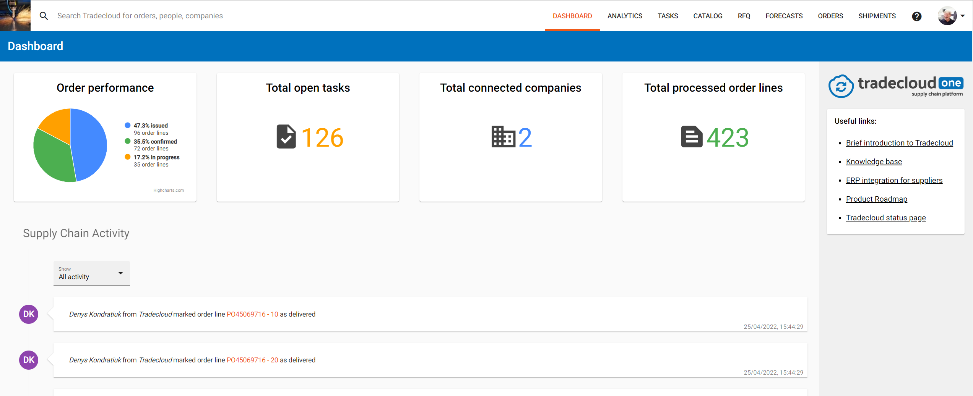
This dashboard contains recent activities.
First, check if there are any “issued” order lines. These are new order lines that need to be confirmed.
If there are “issued” order lines click on the “Total processed order lines” block or on “Orders” in the top menu.

The following screen appears:
Unfold the “Process status” filter box and select “issued”.
You will see an overview of all “issued” orders.
Click on one of the orders to open the order detail page.
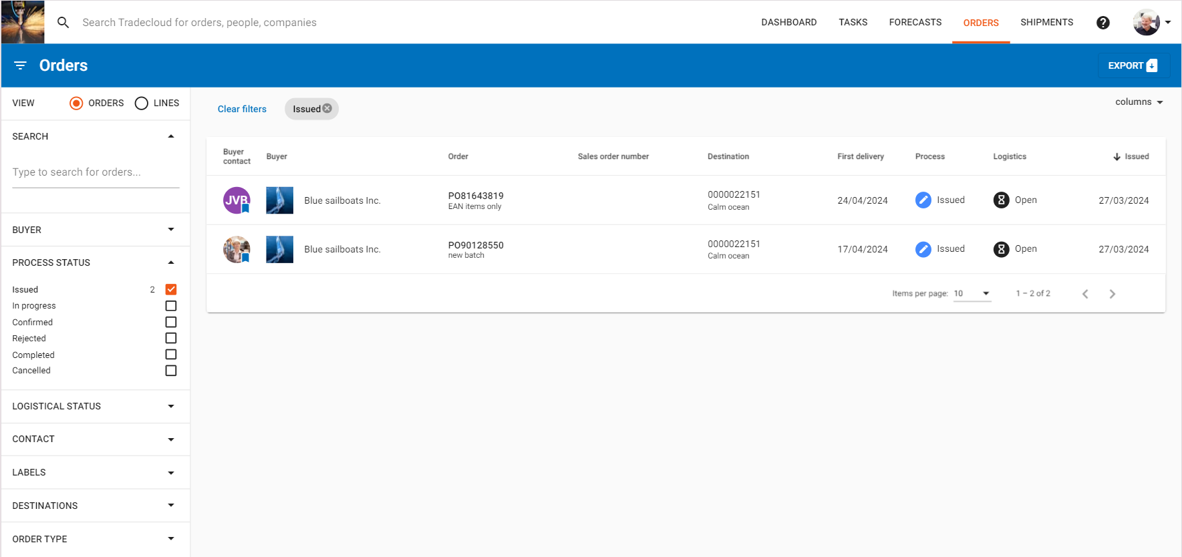

The following screen appears:
You can check the order details, fold and rearrange the data sections as you like by using the buttons at the top left of each data section.
The order in this example contains 3 order lines. These can be selected in bulk via the bulk select function on the left.
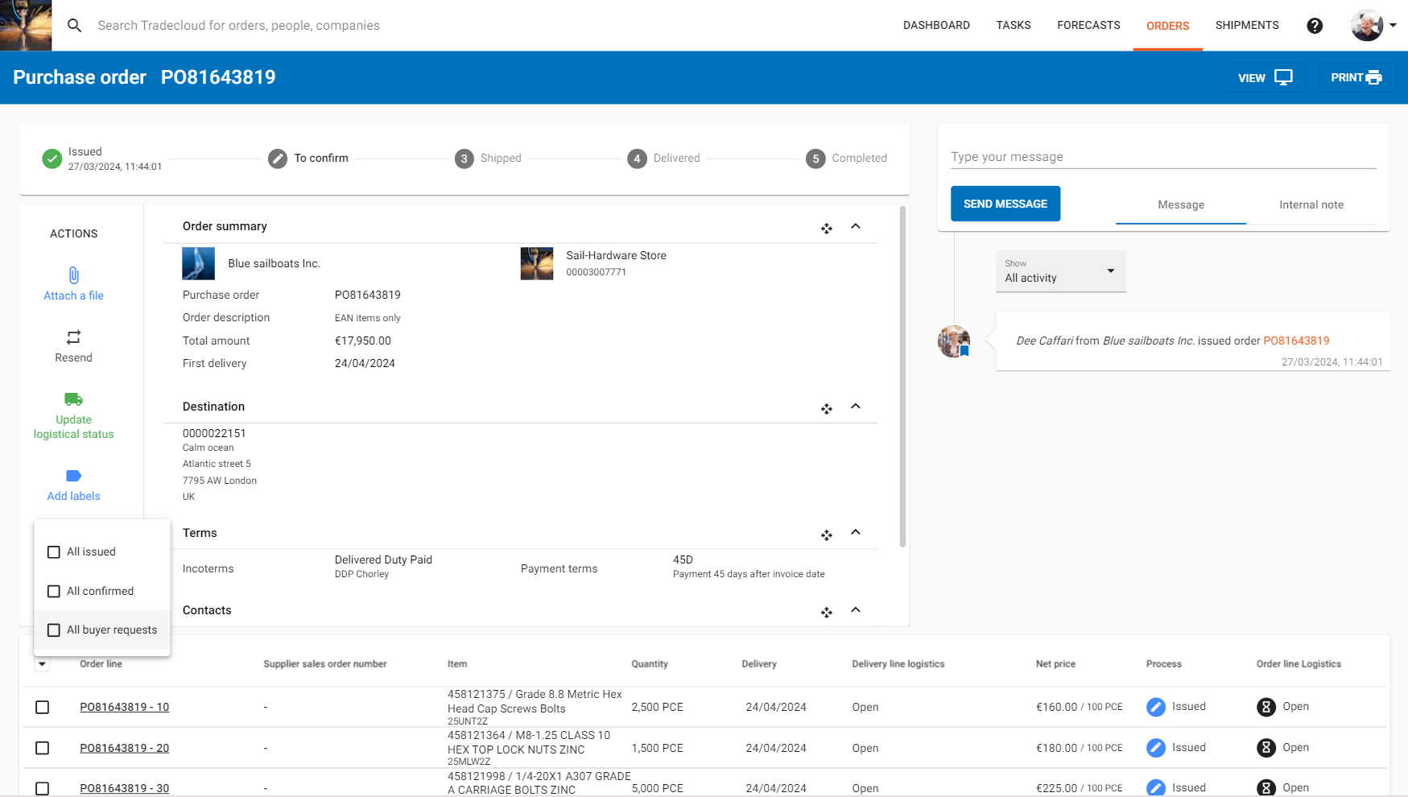
We will confirm lines 10 & 30 in this example, so we deselect line 20.
After deselecting, click on the green “confirm” thumb.
A popup will be shown where you can enter your sales order number.
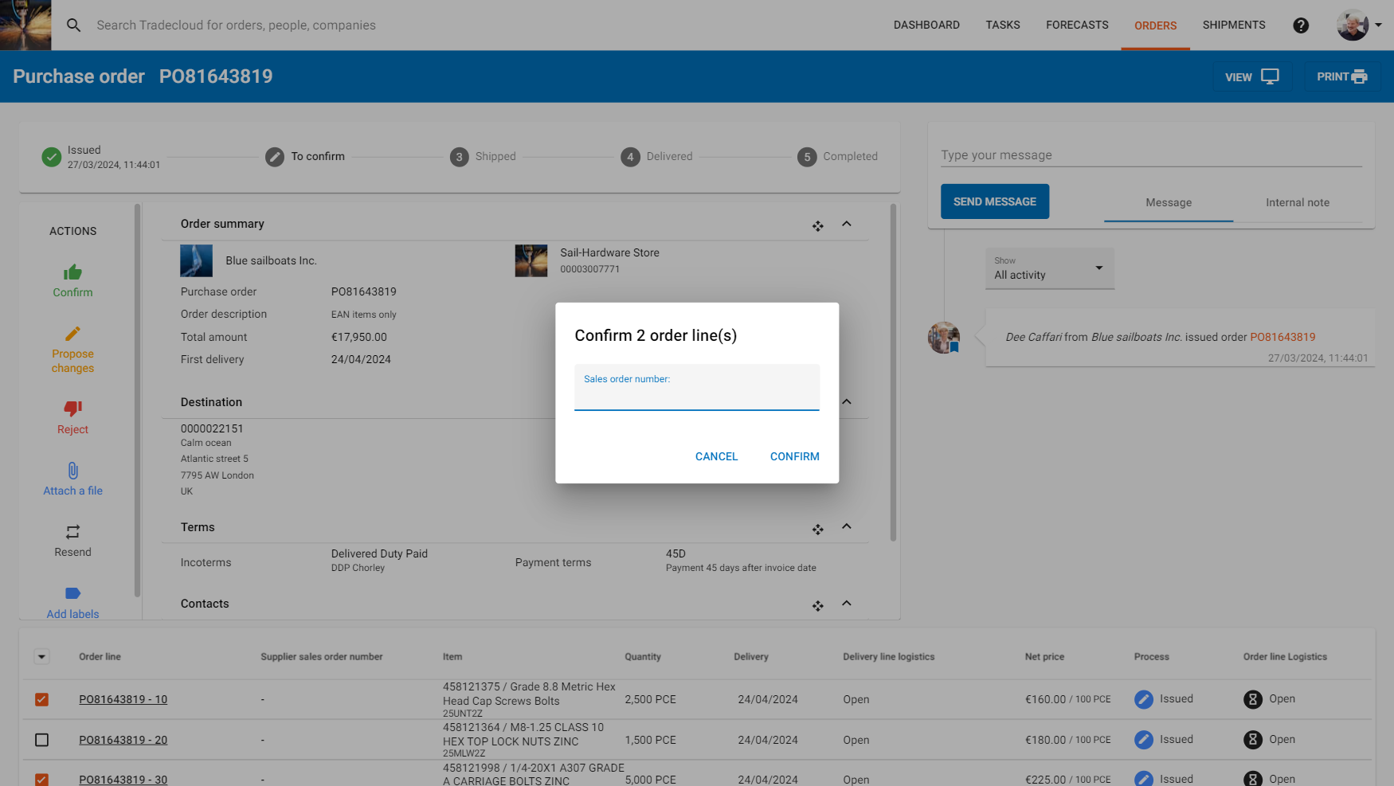
After you press the “confirm” button, the following screen appears:
Lines 10 & 30 have the status confirmed. For line 20 we want to propose a split delivery.
This can be done on the same screen by selecting line 20, but in this example, we will open de order line and propose changes from there. Open de order line by clicking on the line number
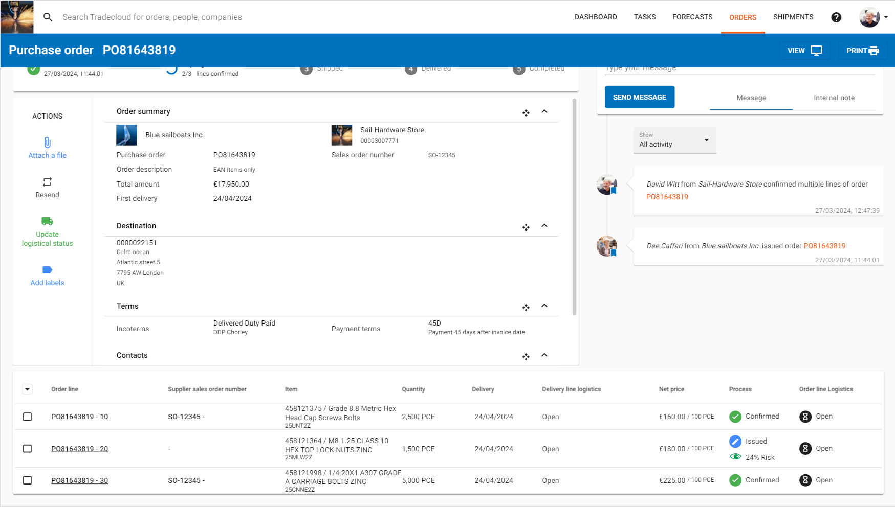

The following screen appears:
Again you can check the order line details, fold, and rearrange the data sections as you like by using the buttons at the top left of each data section.
Click on the “Propose change” on the left to propose a split delivery.
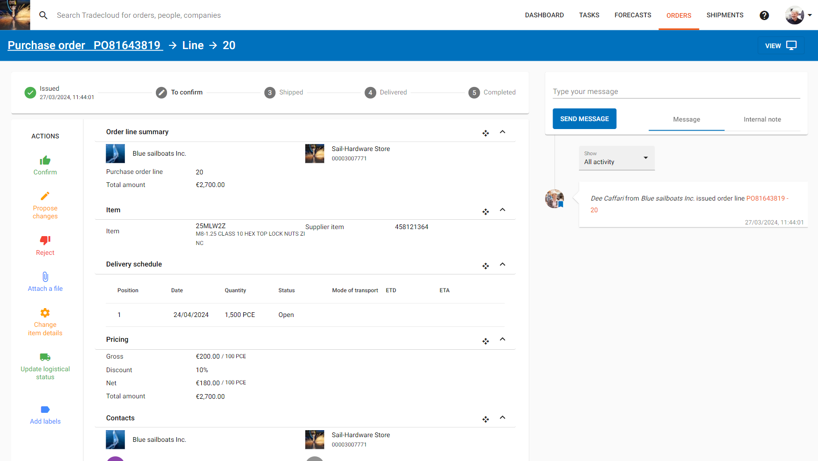
The following screen appears:
Enter the reason for your proposal in the “Reason” field.
In the popup, you can propose changes related to quantity, delivery date, and prices.
In this example, we will propose a split delivery. Click on the “+” to add an additional delivery moment. Enter a quantity and a date, then click on “propose changes”.
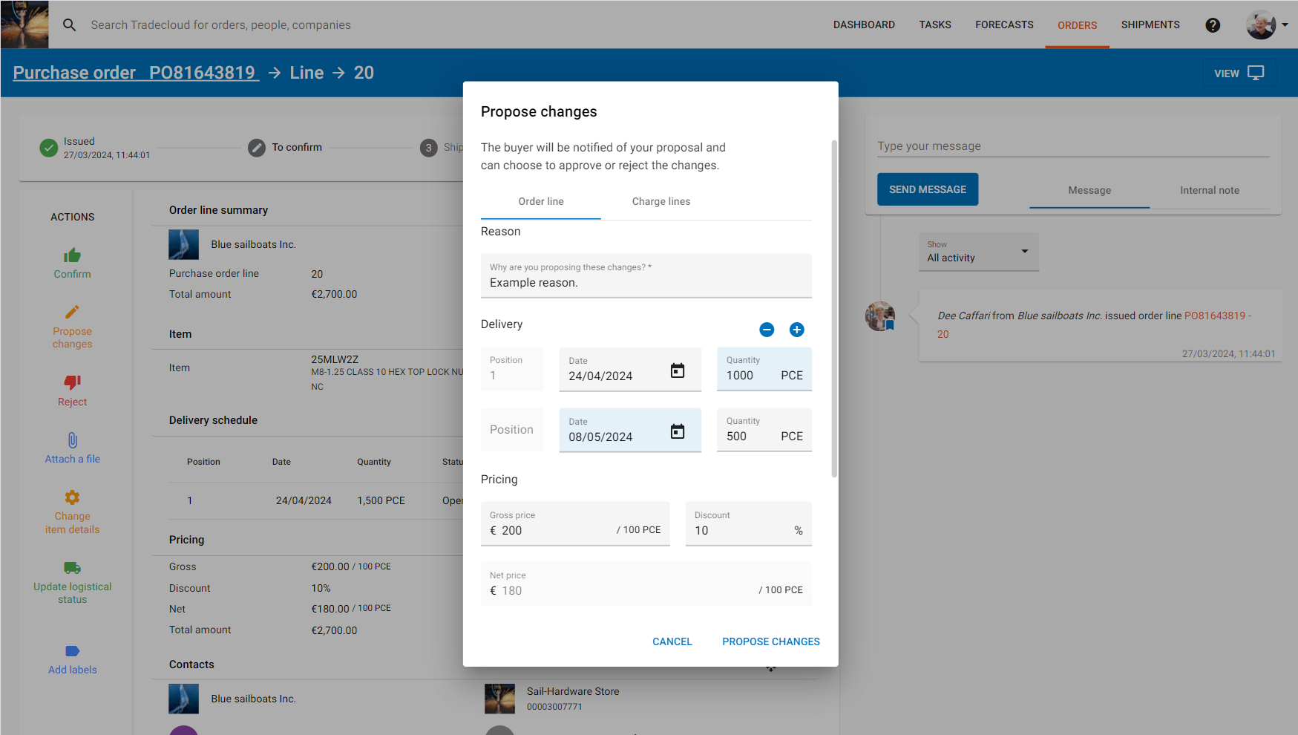

The following screen appears:
Your proposal is logged and all changes are highlighted.
The changes are now visible to your customer and may or may not be approved.
If the changes you have made are approved, you will not receive a notification (If you want to receive a notification, check https://www.tradecloud1.com/en/knowledge-base/category-2/functionality/tasks/acknowledge-tasks-alerts/).
If the proposed changes are not approved, you will receive a new task.
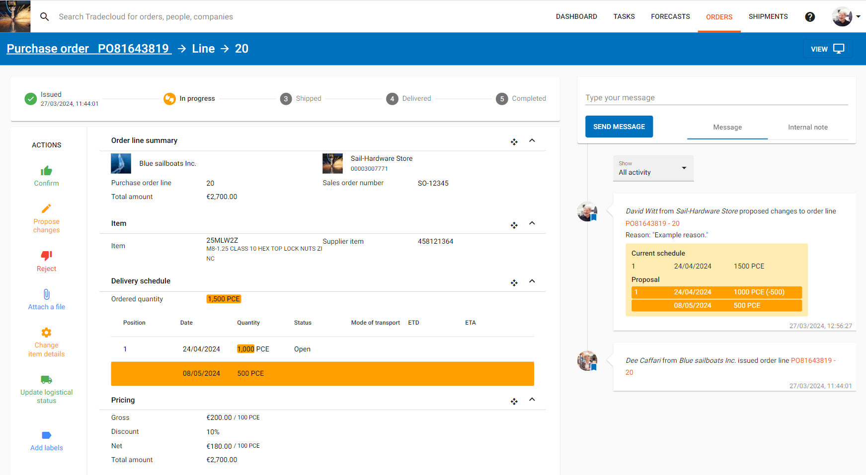
Go back to the order overview page by clicking on “orders” in the top menu.
Repeat the previous steps until you have confirmed all “issued” order lines.
Then click on “tasks” in the top menu.
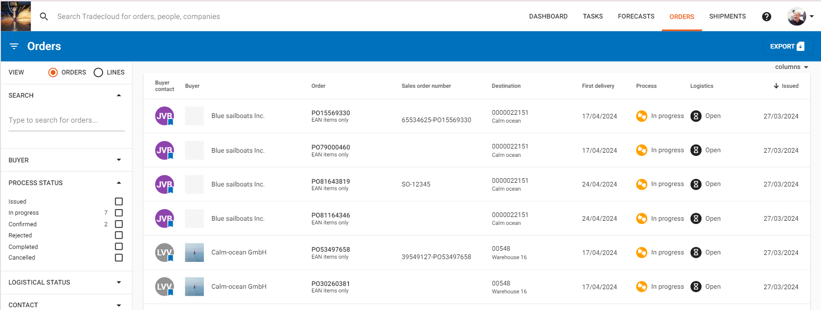

The following screen appears:
On the tasks page, all your tasks are listed, such as requests from your customers and questions.
Unfold a task and perform the task.
If you want more information related to the order line, click on the order line number and the order line detail page will be opened.
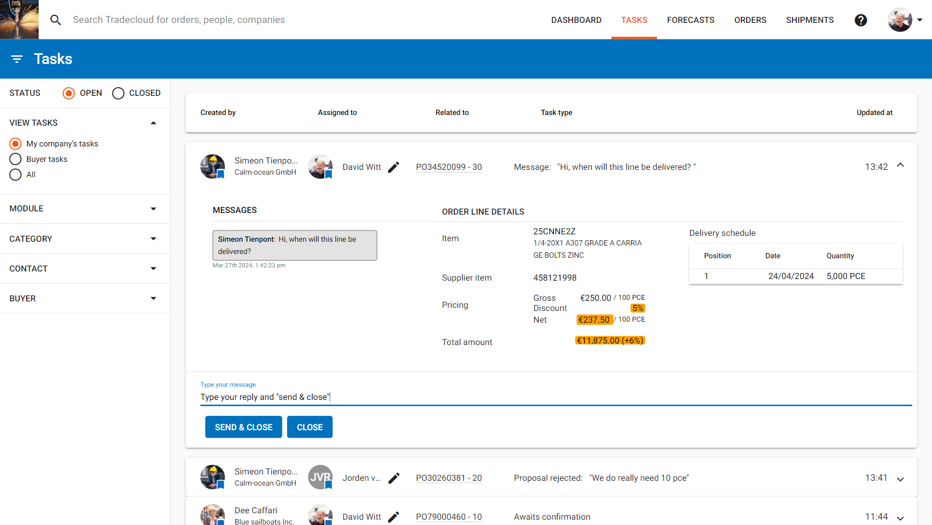

When all tasks are closed you are done.
Whenever there are new tasks available for you, you will get an email notification.

For more information about the Tradecloud platform, check: https://www.tradecloud1.com/en/knowledge-base/

