Manual for using Tradecloud.
1: receiving and processing orders.

You will receive a notification by email that an order is ready in Tradecloud.
Click on the link and the following screen will appear:


Once logged in, the following screen will appear: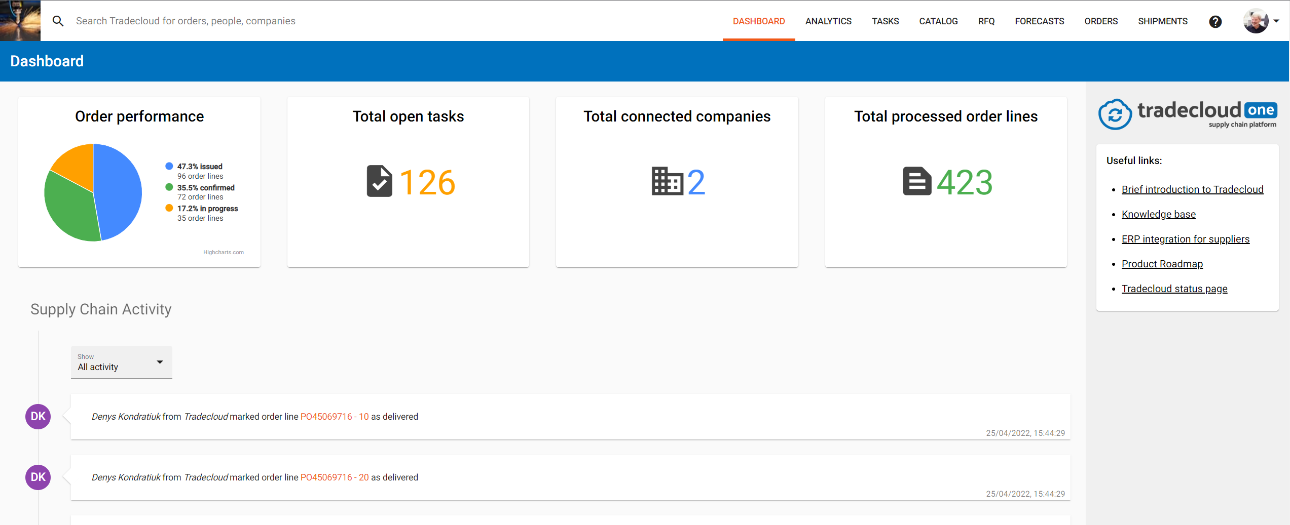

This dashboard contains the activities.
(in this example a purchase order with some documents has been added)

Then click on total number of open tasks and the following screen will appear:
(make sure that the status “open” is selected)

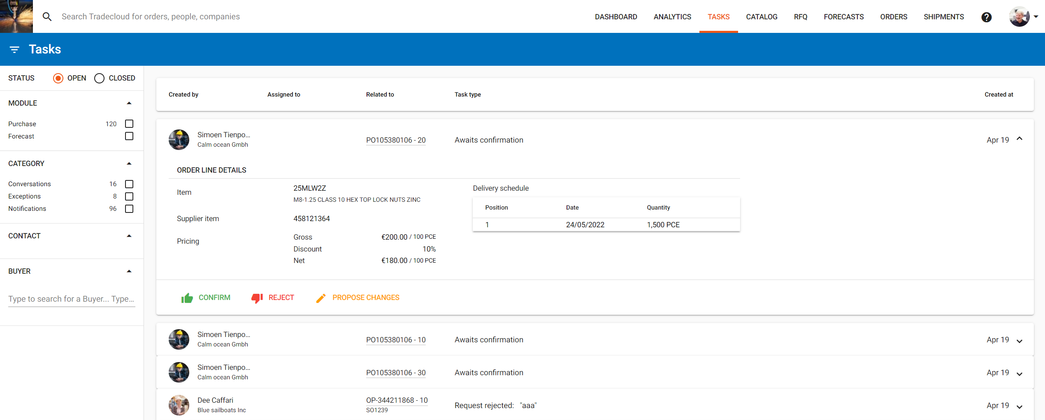

Several orders still need to be confirmed.

Click on the order line which you want to confirm, or whose contents you want to see and the following screen appears: 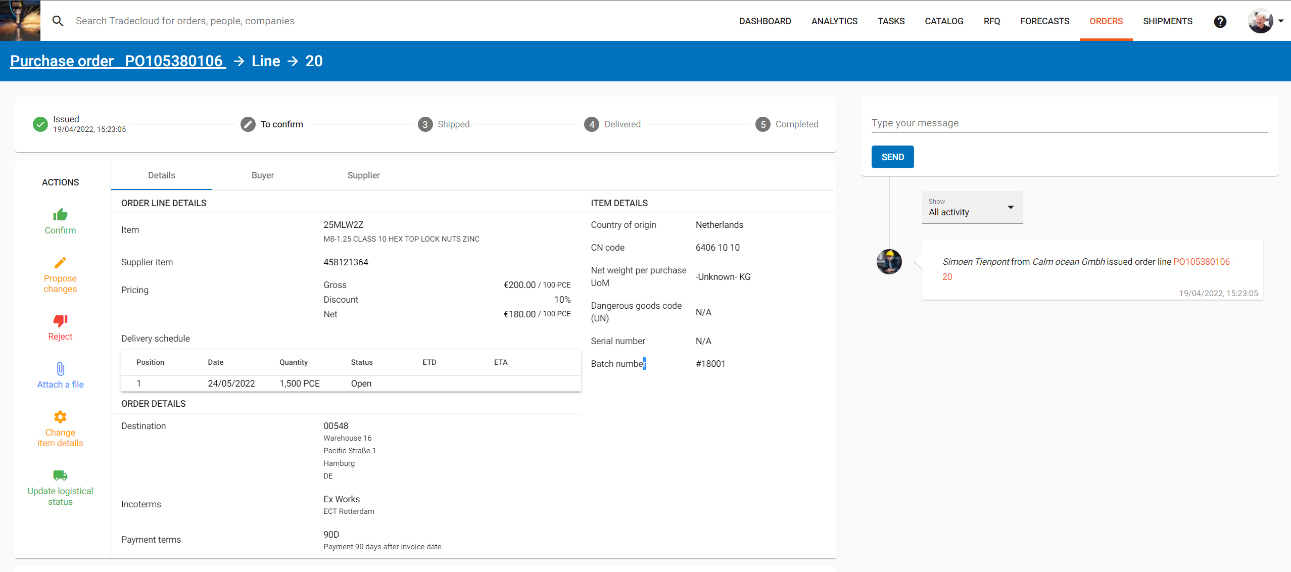

On the details tab you can see the item, quantity, price and the desired delivery time.
On the “customer” tab you will see a link to the relevant drawing. If you click on this, the drawing will open in various formats (PDF, DXF and/or STP), you will also see the order in PDF format.
Click on the blue link under our order number and a PDF document will open.

Your details are visible on the “supplier” tab.
To confirm the order, you need to open the “details” tab.
In this example, we assume that line 1 is OK.
You click on the green thumb and the following screen appears
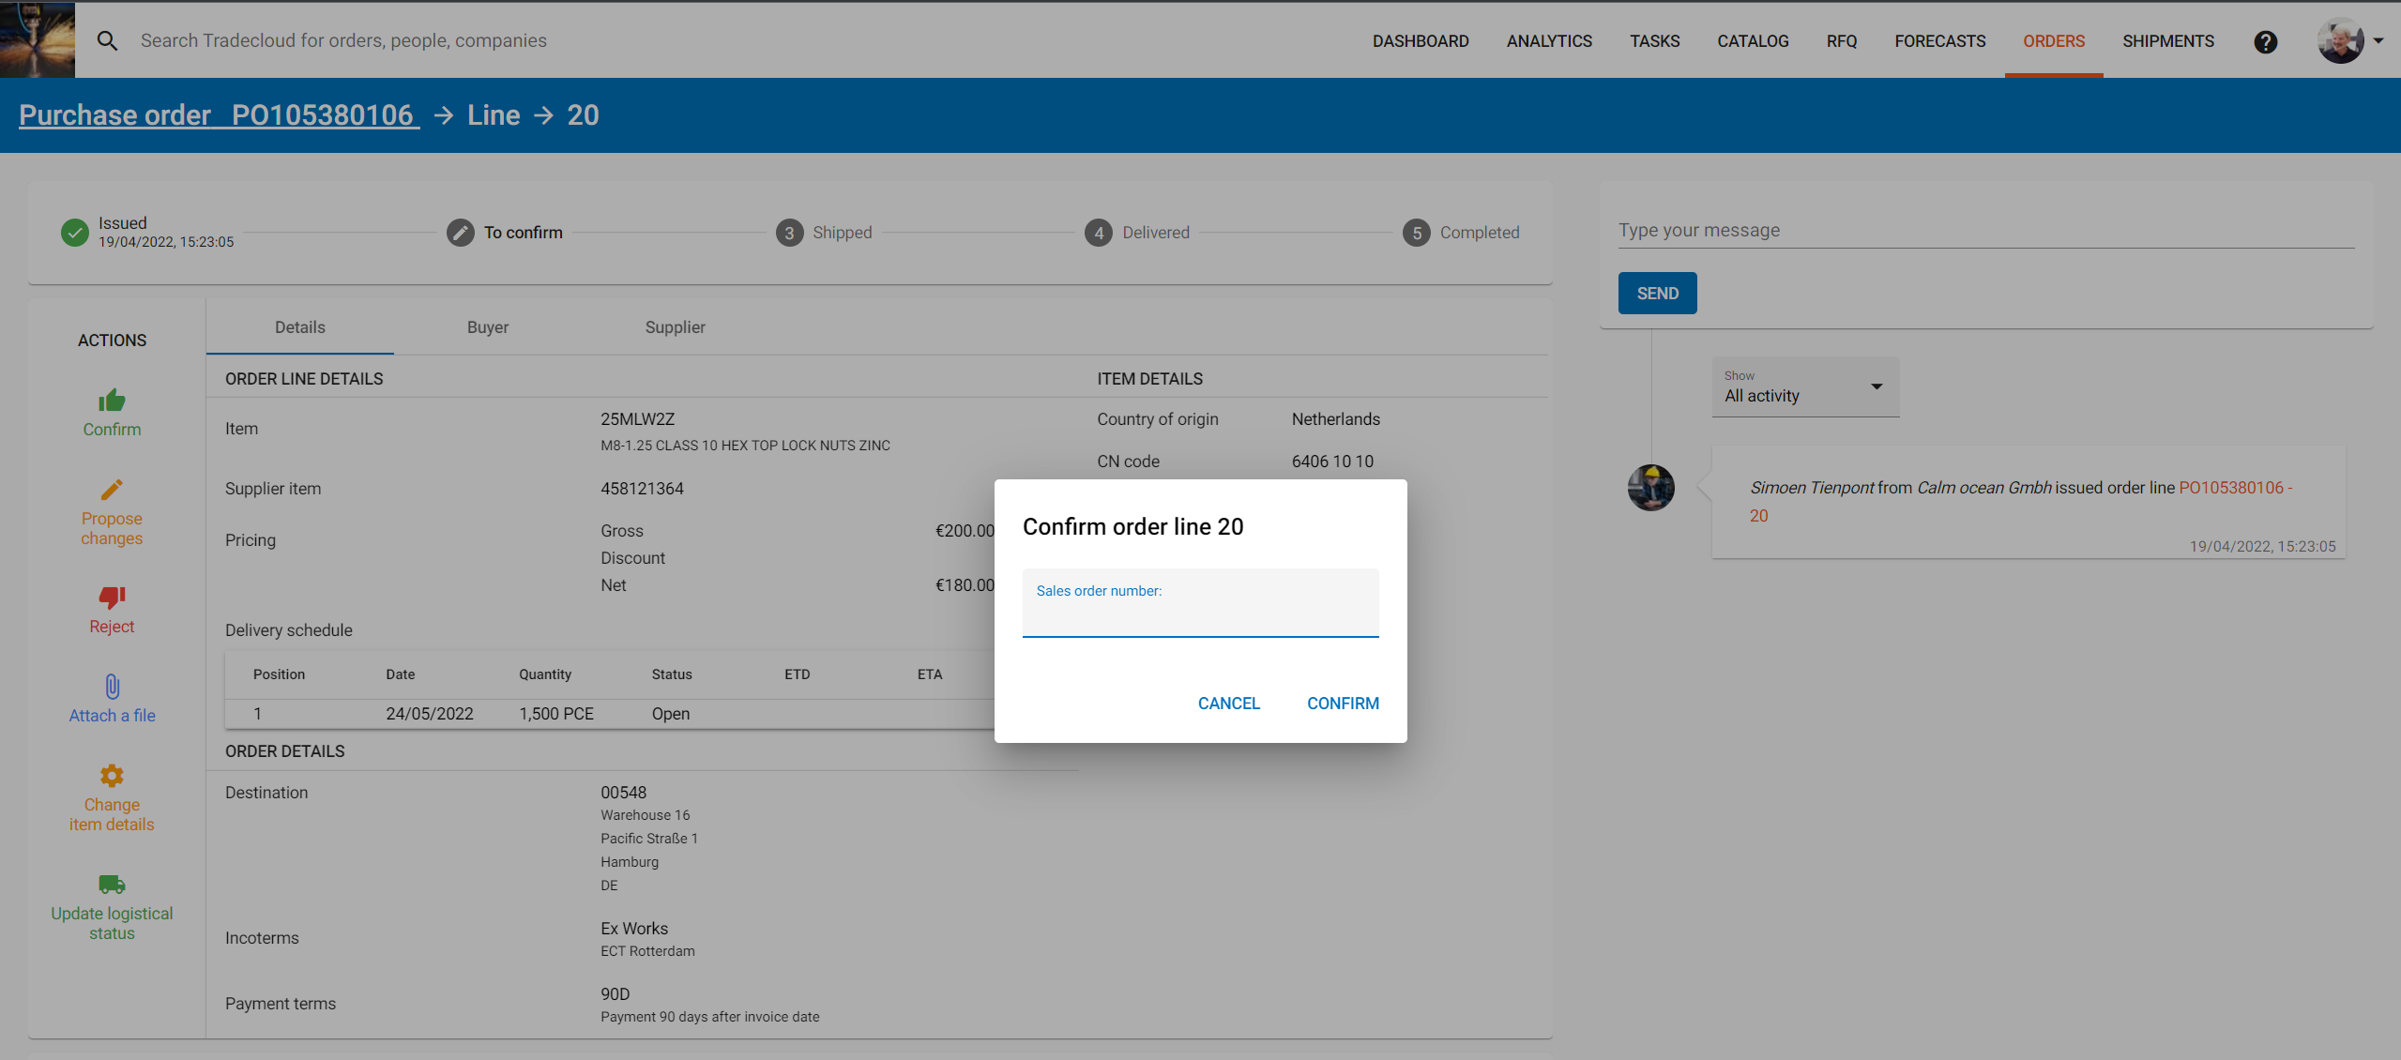
Enter your reference here (sales number, confirmation number) and click on confirm. the next screen appears:
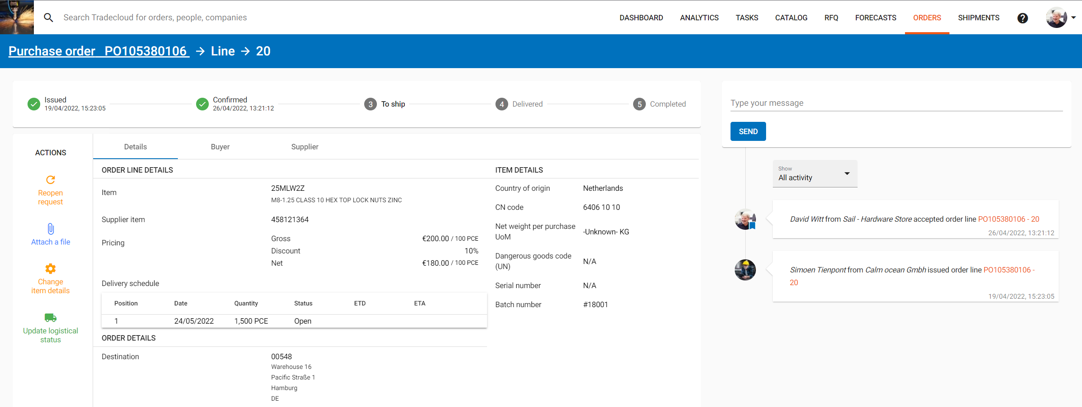
You will now see a green check mark appear at the top of the screen with the date and time that the order was confirmed by you.
There are 2 options to confirm the next line:

1: you click on dashboard again and repeat all the above steps or you click on the order number in the last discussed screen (in this example 450104684)
2: you click on the order number and the following screen appears:

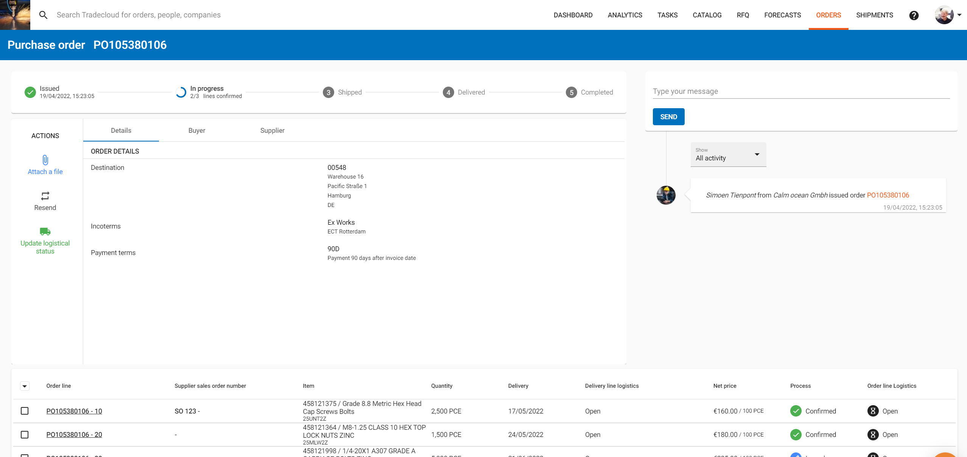
At the bottom of the screen you will now see both lines from the purchase order, whereby line 1 has now been confirmed and includes your order reference.
We are now going to confirm rule 3, but with a few changes.
Click on the line number (in this example line 30)
The next screen appears:
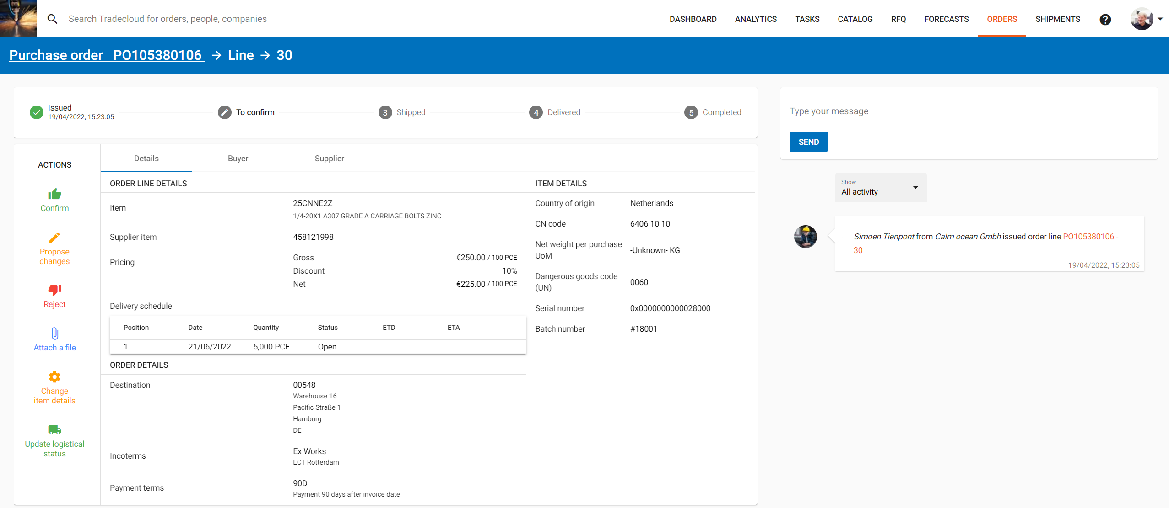
You do not agree with the data as stated in line 2 and want to inform us about a number of changes.
Click on the pencil “propose changes” and the following screen will appear: 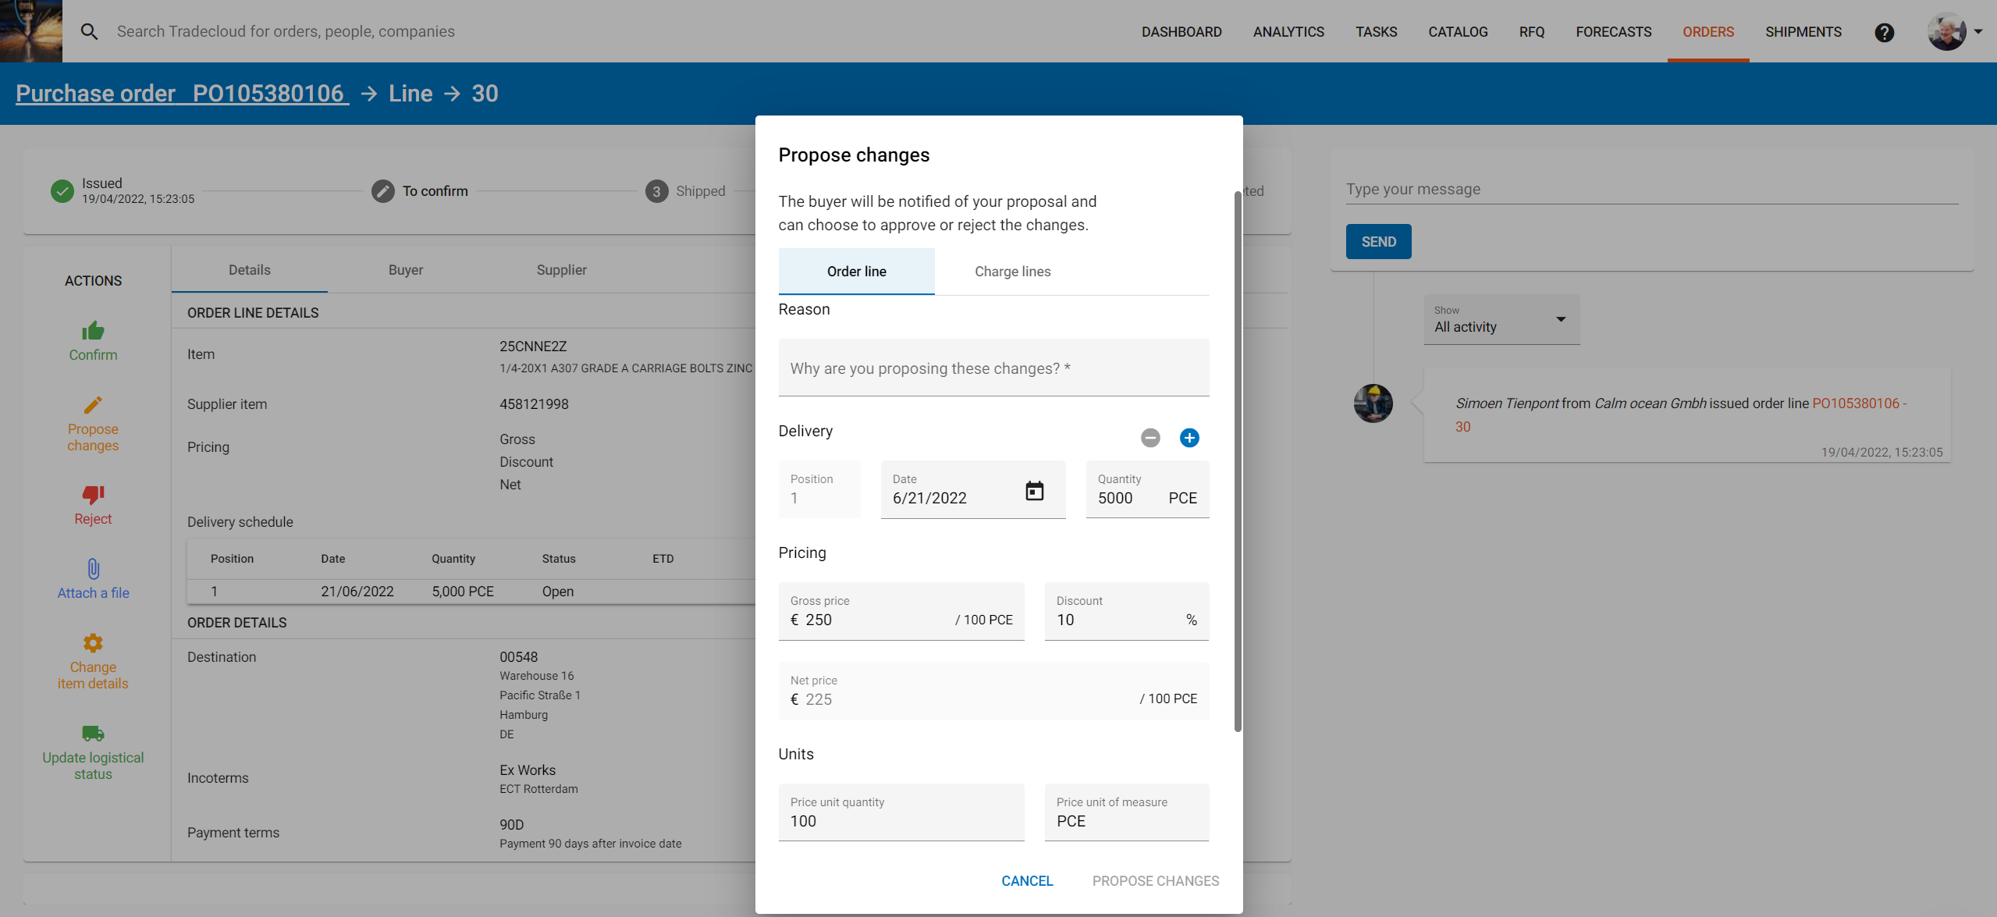
Enter a reason why you want to propose this change.
In this example, the supplier has insufficient stock to deliver on the requested lead time and wants to propose a partial delivery.
To create a receipt line, click on the + and enter the date, quantity and any price and discount. 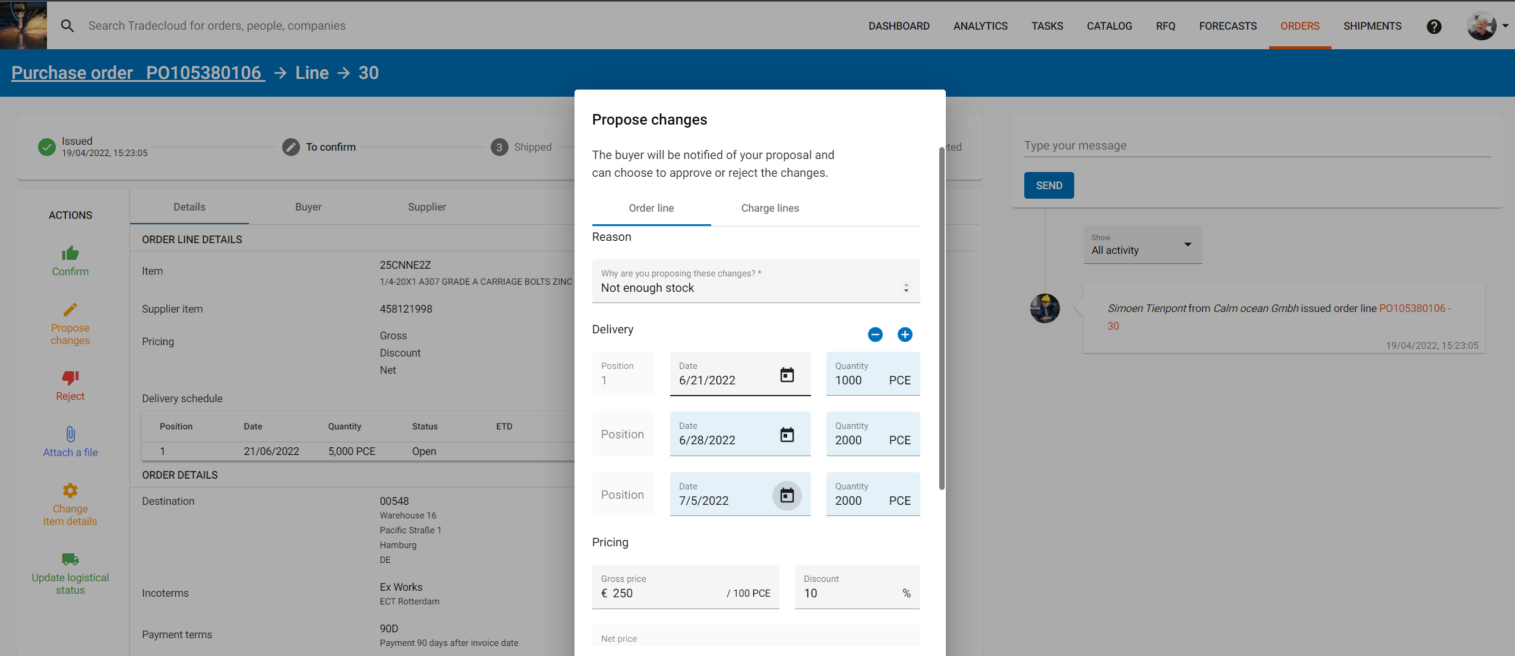
After you have made all changes in the input form, click on “Suggest changes” and the following screen appears, with the changes you have made:

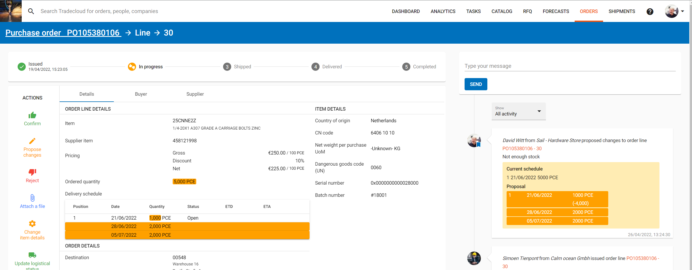

The status of the order changes to “pending”.

The changes are now visible to X and may or may not be approved.
If the changes you have made are approved, you will not receive a notification.
If the proposed changes are not approved, you will receive a new task.
Log back in and view your new task/notification.

